sounds of recovery: song meter micro guide

Summary
This procedure describes how to set-up Song Meter Micros used to record nocturnal birds and mammals for the “Sounds of Recovery” project. It also explains what additional data should be collected while in the field and troubleshoot possible issues.
Click this link for a video demonstration of the following: Song Meter Micro: Quick Start | Wildlife Acoustics

What to bring when doing a hot swap
To perform a hot swap, you need to bring in the field:
- Three (3) fully charged AA batteries for each unit to be swapped,
- One (1) microSD card for each unit to be swapped,
- A mobile phone with the “Song Meter Configurator” app already installed (download for iOS or Android),
- A notebook or other device (e.g., your phone’s notes app) to record information in the field,
- A GPS or map with coordinates for each of the sites to hot swap.

song meter micro anatomy

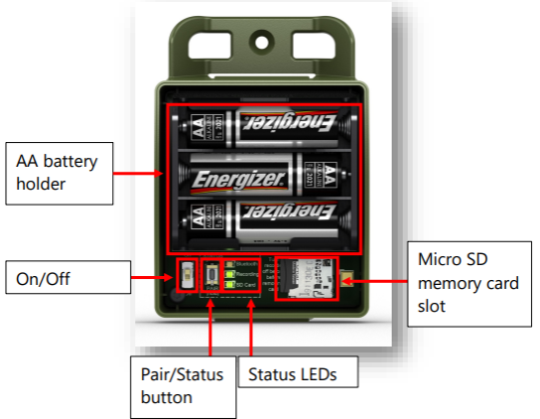

Setting up your song meter micro

Step 1
Remove the lid from the Song Meter Micro recorder.
Lift up and out here

step 2
Insert three AA alkaline or NiMH batteries and a microSD card. TIP: In environments of high humidity or wide temperature changes, it is worth inserting a silica desiccant pack before deployment.
Insert microSD card here

Step 3

Switch the recorder’s Power switch to On.
Switch to the top, ‘ON’ position

Step 4
If the Bluetooth LED flashes red this indicates that the recorder’s internal clock is not set. Do not worry, it will be set when pairing the recorder with the Configurator app.

Step 5
Install the Song Meter Micro configurator app from the Apple App store or Google Play store (for Androids) onto your mobile device.
- Apple users: Song Meter Configurator on the App Store (apple.com)
- Android users: Song Meter Configurator – Apps on Google Play

step 6
Make sure Bluetooth is enabled on your mobile device.
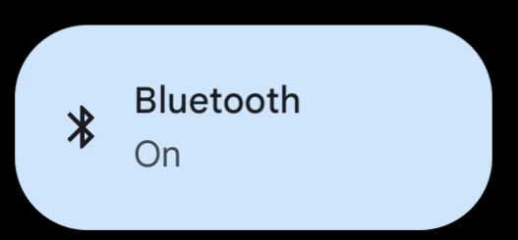

step 7
Launch the app. The Song Meter Micro will be detected by the app and will appear in the Recorders screen.

step 8
Press and hold the Pair button on the Song Meter Micro recorder for 3 seconds. The Bluetooth LED on the recorder will blink green, indicating it is ready to pair.
In the app, tap the Pair icon in the Recorders screen.
Until you see this icon
2
Hold down this button
1

step 9
A pop-up asks if you want to set the Recorders time zone to your mobile device’s time zone. Tap OK. Next, a pop-up asks the same about location. Tap OK.
If you want to confirm the status of the recorder, click on the ‘Status’ icon from the ‘Recorders’ screen.

step 10
After pairing, tap the Configure button for the paired recorder in the Recorders screen. The Configuration Editor screen will open.
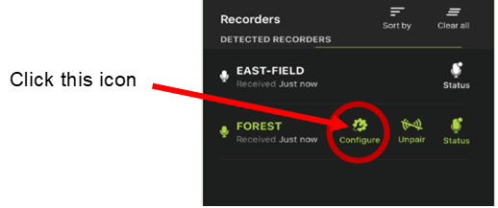

step 11
Select a preset recording schedule from the drop-down menu and make any desired setting changes. A list of preset shedules can be found in appendix 1.
(Tip: a good preset for songbirds is the dawn/dusk schedule)
The recording schedule and settings changes load onto the recorder immediately after each change.
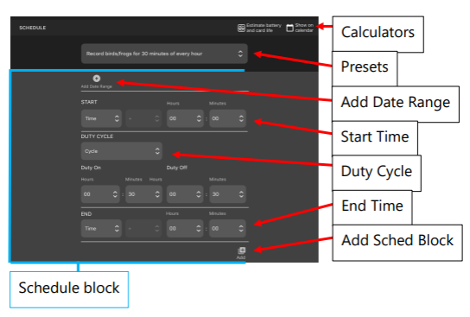

step 12
Tap the unpair button on the recorders screen. Replace the cover The Song Meter Micro is now ready to deploy and record.

Click this

step 9: unpair and replace the cover on the song meter micro
Once you’re finished checking the status, unpair the device on your phone. Make sure the silica pack is in the box, then replace the cover. This can be a bit tricky – you’ll need to slide the cover on, then press down and in on the top. You should hear two clicks and the lid should be firmly attached to the base.
Press down and slightly inward here (both sides at the same time)

extraction and Data collection
These steps will cover the process of replacing batteries and microSD cards.

step 1
Return to your recording device. Using the notebook or notes app on your phone, record at a minimum:
- the recorder name (e.g., ‘SMM03’) and the number on the microSD card (which may match the recorder name).
- Any information you think might be helpful, including
  - any problems you had when swapping the card and batteries,
  - water in the unit
  - tampering with the unit
  - observations within the site (e.g., flooding, tree damage, etc).

step 2
Remove the lid and switch the power to ‘Off’. Gently press on the end of the microSD card and it will release from the holder. Place this card in a bag or box for safekeeping (we use small, plastic jewellery bead bags).
Before putting in a new microSD card, be sure to take a picture of the card against the Song Meter Micro in the field. This helps to maintain accurate records of what SD cards have been used and where.
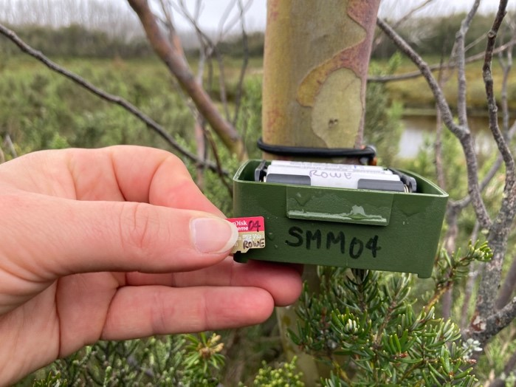
Replace with the fresh microSD card by gently inserting and pressing into the sleeve.

step 3
Remove the three (3) AA batteries. The casing in which they sit can be tight so be it may take a bit of fingernail strength (or a tool) to remove all three. Replace with the fresh AA batteries. Be sure to store the ‘dead’ batteries separately to the fresh ones!

step 4
Turn the unit back on. Follow the same steps set out earlier in this manual to set-up the recorder again, remembering to re-pair the device to the Song Meter phone app.

step 5
Occasionally problems occur with recordings if there are issues with the microSD from a previous deployment. It’s always good practice to format the ‘fresh’ microSD card just prior to deployment to ensure a ‘clean’ card.
To format the microSD, click on the green ‘Configure’ icon for that recorder.
Click this icon

On the configuration screen, click the ‘Utilities’ icon in the upper right.
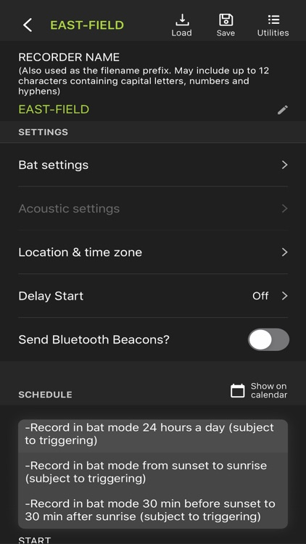
A pop-up screen will then appear. Select ‘Format SD card’. Select ‘Yes’ when it asks if you want to proceed. You’ll then get a message once it’s formatted the card.
Click this

Then this icon

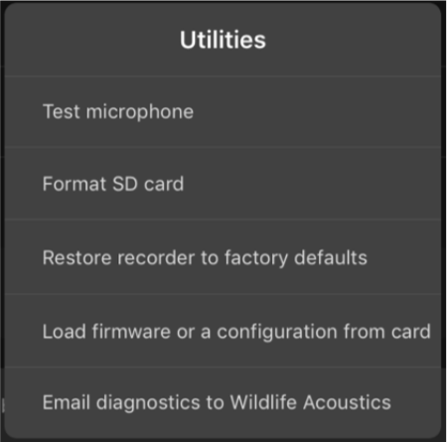

step 6: Confirm the recorder is ready
Once you’ve formatted the card, the device should be ready to go. The configuration program (the recording schedule and settings) is already programmed on the device. You do not need to update the location as the recorders are remaining in the same place.
If you want to confirm the status of the recorder, click on the ‘Status’ icon from the ‘Recorders’ screen.
Click this icon

The ‘Status’ screen will show you how much space is available on the SD card you installed, battery power, recording schedule, and time of next recording. A recorder that is ready will have:
- 0 GB for the ‘Used’ ‘Storage Info’,
- Sufficient battery voltage (at least 88%, although sometime the app will read low for battery voltage, so not always a reliable way to know!),
- ‘Custom Schedule’ for ‘Schedule Name’,
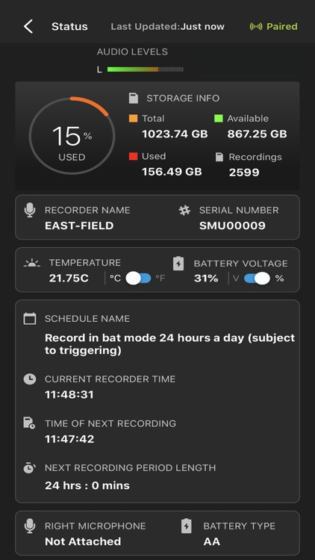
- And a ‘Time of Next Recording’ that is within ~ 10 minutes.
SD card storage
Battery voltage
Time to next recording

step 7: unpair and replace the cover on the song meter micro
Once you’re finished checking the status, unpair the device on your phone.
Click this

Make sure the silica pack is in the box, then replace the cover. This can be a bit tricky – you’ll need to slide the cover on, then press down and in on the top. You should hear two clicks and the lid should be firmly attached to the base.
Press down and slightly inward here (both sides at the same time)

Troubleshooting
Some common problems you may encounter and possible solutions:

device doesn’t pair
Sometimes when you try to pair the device by holding down the ‘Pair’ button on the device, it doesn’t show up. In this case, try turning the device off and on again, then try to pair.

schedule file does not appear on the device
If the schedule file does not appear, or does not read ‘Custom Schedule’, you can reload the file from your configuration library. Simply press the green ‘Configure’ icon on the Recorder screen, then ‘Load’ in the upper right to load the configuration file.

Appendix 1: tips

Preset schedule
The following preset schedules are available for use:
- Record birds/ frogs 24 hours day (comprehensive collection of calls but will create lots of data and consume battery very quickly)
- Record birds/ frogs for 30 minutes of every hour
- Record birds/ frogs for 5 minutes of every hour
- Record birds/ frogs from sunrise to sunset
- Record birds/ frogs 2 hours around sunrise and 2 hours around sunset

update location
Every time you check the recorder on-site, always update the location on the app (a prompt will appear automatically after pairing with recorder).

naming
A helpful naming convention is to use the last 4 digits of the serial number.

appendix 2: SITE SELECTION TIPS
- Attach the device to a natural feature (i.e. a tree). You can attach to a stake if there are no other options, but its is best to avoid disrupting the soil. Make sure no leaves are touching the device.
- Try and keep the device at least 1.5m away from vegetation, obstructions or open water.
- Place the recorder at head height (if possible)
- It is advised to place the AudioMoth in an area with some shade or canopy to block direct sunlight, in order to avoid overheating of the batteries.
- If possible, deploy recorders 50-100 meters away from roads or any other source of noise unless you have a specific question/goal associated with the impact of noise on biodiversity
- The optimum distance between each AudioMoth: The team typically recommends 400 m or greater when possible, having 200 m as the absolute minimum. As well as a height of 1 meter to 2 meters above the ground.
  - Depending upon the species you are interested in, an even greater distance may be required. E.g., if researching Powerful Owls, try and separate AudioMoth’s by at least 2km. This is due to the Owls large territories.

