Sounds of recovery: audiomoth guide

Summary
This procedure describes how set-up and configure AudioMoths used to record nocturnal birds and mammals for the “Sounds of Recovery” project. It also explains what additional data should be collected while in the field and troubleshoot possible issues.

what you will need
- Three AA batteries (3.9 voltage)
- One MicroSD card
- Snaplock box
- Silica gel bag
- Zip tie cable(s)
- A notebook or other device (e.g., your phone’s notes app) to record information in the field
- Camera or mobile phone camera

Initial set-up

Step 1
Insert batteries and SD card into your device.

step 2
Now, set the switch to ‘USB/OFF’.
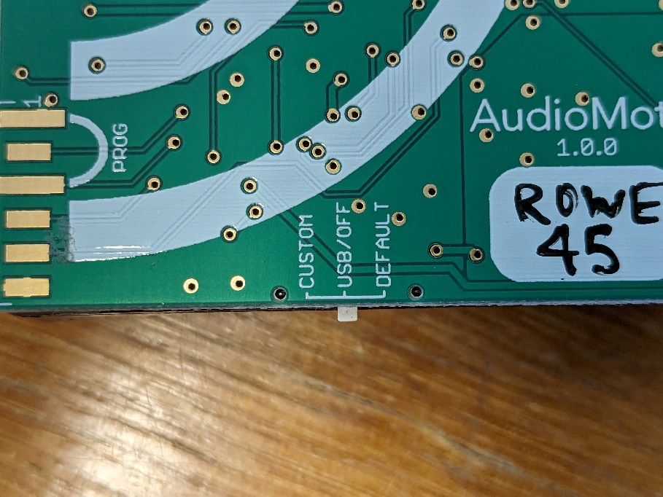

Step 3:

- Download the AudioMoth Configuration app: https://www.openacousticdevices.info/applications

Configuration

Step 1
Attach your AudioMoth to a computer via a micro-USB cable.
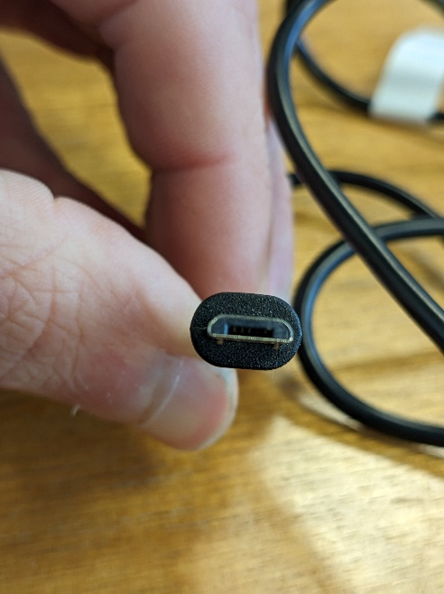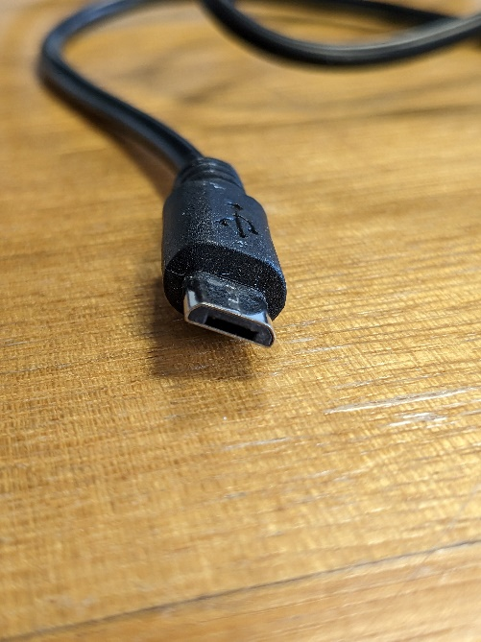

Step 2
Open the Configuration app. Go to ‘File’ on the top-left corner and select ‘Open Configuration’. Select the relevant configuration and click ‘Open’.
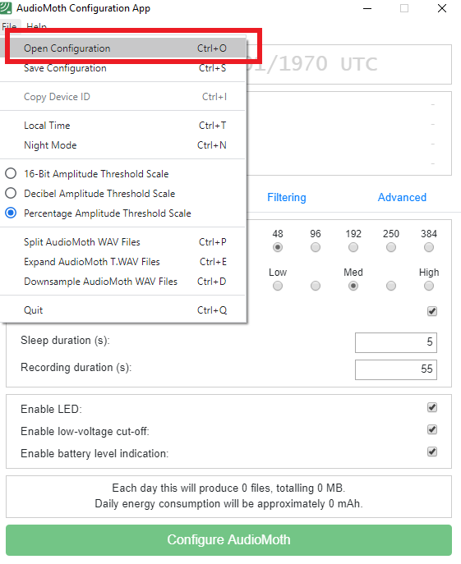

Step 3
Ensure the AudioMoth is set to local time by selecting ‘File’ (top, left) and selecting ‘Local Time’.
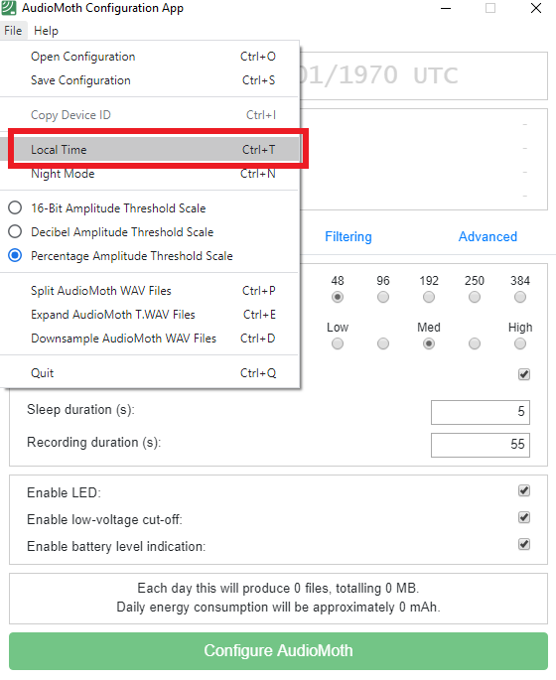

Step 4
Click ‘Configure AudioMoth’ to apply the configuration. Repeat three times, to ensure the configuration has been applied. Make sure that the clock switched to your computer’s time.

Deployment

Step 1
Handle the AudioMoth carefully. Careless handling could cause a configuration loss, either due to the movement of batteries or the accidental ejection of the microSD card. In addition, it can cause the breakage of the main switch.

Step 2
Turn the switch from ‘USB/OFF’ to ‘CUSTOM’.
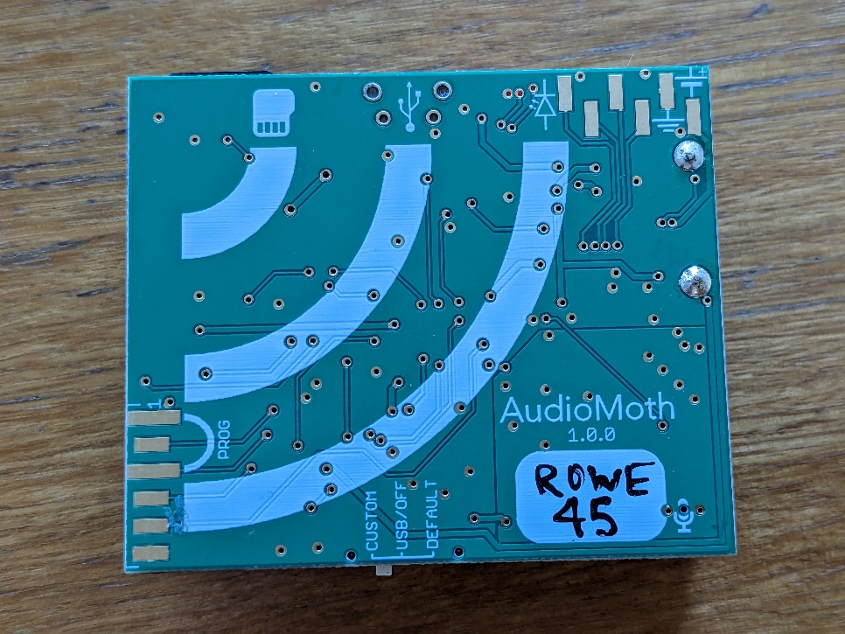
There are two LED lights (one red, one green) that may flash when you’ve done this.
- A rapid red light indicates the recorder has started recording
- A slower green light indicates the recorder is working but waiting until the next recording begins

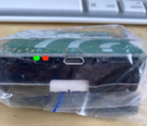

Step 3
Place AudioMoth into provided snaplock case. Ensure microphone is facing towards the hole in the case (look for the small microphone symbol, highlighted below).
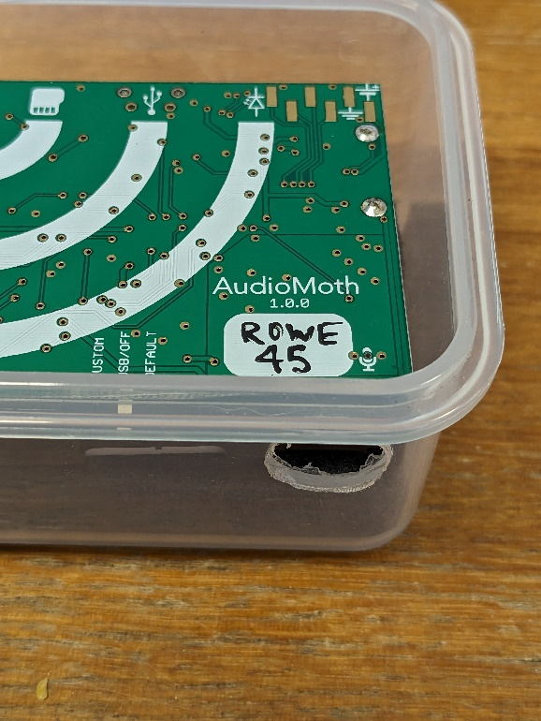
Case hole
Microphone
Then place the silica bag on top, before closing the case.
2
1
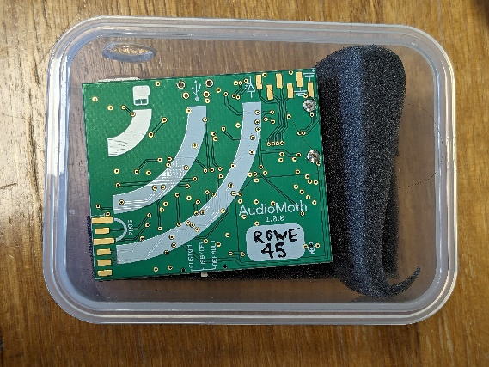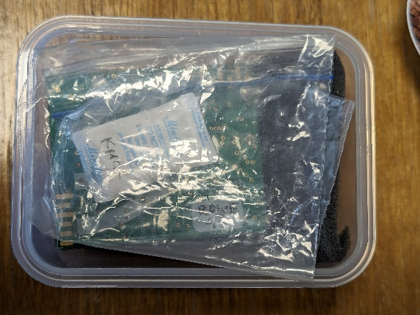
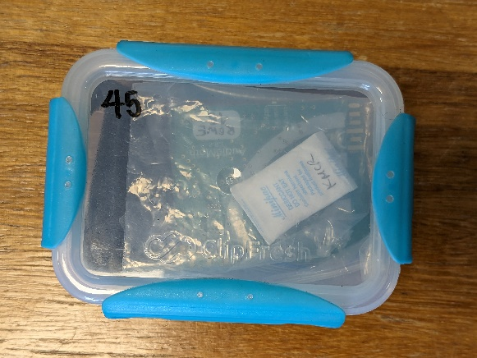
3

step 4
Choose an appropriate site. Using a bungee cord or rope, attach the box to a sturdy structure (at head height if possible) with the case hole pointing down. See Appendix 1 for more site selection information.

step 5
Take a picture of the survey point front on and from the perspective of the AudioMoth and record the GPS coordinate Also take at least two habitat photos. This helps to ensure you remember where each device is placed and a general reminder of the sites habitat (at the time of deployment).
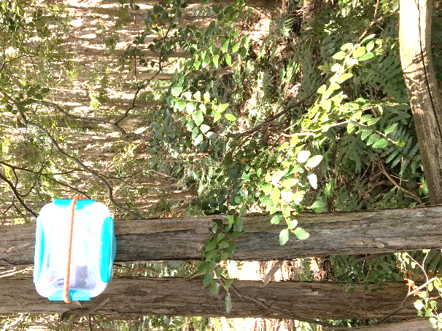
Take a photo like this one

Congratulations, you’re AudioMoth is set-up and ready to record!

Extracting data

step 1
Return to your recording device. Using the notebook or notes app on your phone, record at a minimum:
- the recorder name (e.g., ‘SMM03’) and the number on the microSD card (which may match the recorder name).
- Any information you think might be helpful, including
  - any problems you had when swapping the card and batteries,
  - water in the unit
  - tampering with the unit
  - observations within the site (e.g., flooding, tree damage, etc).

step 2
Transport the AudioMoth to a dry location and remove the batteries.

step 3
Switch out the MicroSD with a new, empty card and insert new batteries.

step 4
Reconfigure the AudioMoth, re-deploy in same location and take another set of photos

appendix 1: SITE SELECTION TIPS
- Attach the device to a natural feature (i.e. a tree). You can attach to a stake if there are no other options, but its is best to avoid disrupting the soil. Make sure no leaves are touching the device.
- Try and keep the device at least 1.5m away from vegetation, obstructions or open water.
- Place the recorder at head height (if possible)
- It is advised to place the AudioMoth in an area with some shade or canopy to block direct sunlight, in order to avoid overheating of the batteries.
- If possible, deploy recorders 50-100 meters away from roads or any other source of noise unless you have a specific question/goal associated with the impact of noise on biodiversity
- The optimum distance between each AudioMoth: The team typically recommends 400 m or greater when possible, having 200 m as the absolute minimum. As well as a height of 1 meter to 2 meters above the ground.
  - Depending upon the species you are interested in, an even greater distance may be required. E.g., if researching Powerful Owls, try and separate AudioMoth’s by at least 2km. This is due to the Owls large territories.

Troubleshooting
Some common problems you may encounter and possible solutions:

Device isn’t syncing to local time
Sometimes it takes several attempts to let the device configure to local time. Be persistent and restart the configuration app and unplug then replug the AudioMoth back into your computer.

BOTH COLOURED LIGHTS ARE FLASHING
If both red AND green lights are flashing, there is a problem with the recorder. You’ll need to substitute another recorder or not deploy one at that site as the recorder will not work.

