9/13/2023
Liam Meredith
Museums Victoria
Sounds of Recovery
Arbimon procedures (Version 1)

Summary
This procedure describes how set-up the Arbimon online platform, used to analyse nocturnal bird and mammal calls for the “Sounds of Recovery” project.

glossary
- Powerful Owl – Ninox strenua
- Masked Owl - Tyto novehollandiae
- Greater Sooty Owl – Tyto tenebricosa
- Baking Owl – Ninox connivens
- Southern Boobook – Ninox boobook

what you will need
- Computer
- Access to reliable internet connection

account creation

Step 1
Go to Arbimon website: arbimon.rfcx.org

step 2
Click on the green ‘Start Analysing Now’ button
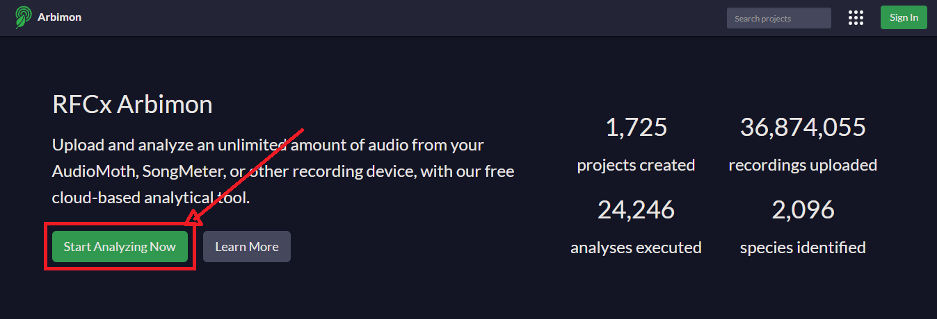

Step 3:
Complete the registration form, read and agree to the terms and conditions, before clicking the green ‘Sign up’ button
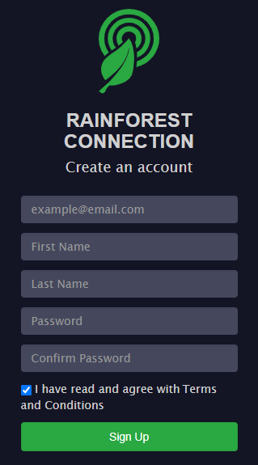

Step 4
Check your email for an email verification and click on the link.
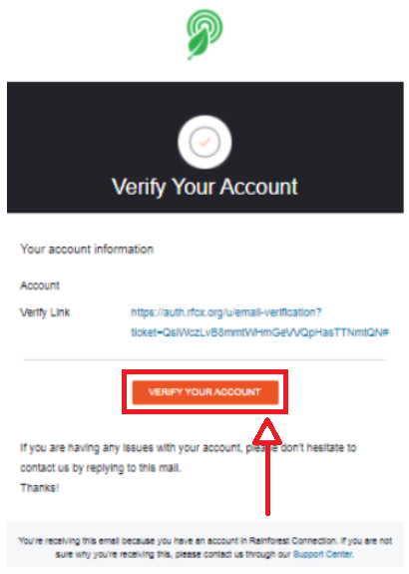

Step 5
You will be redirected back to the log-in page for Arbimon. Your account is now set-up and you can log-in!

join the project

step 1
Email your login name/ email to: LMeredith@museum.vic.gov.au. Your account will then be added to the Sounds of Recovery project.

Create a site

Step 1
From the main menu (found at the top of the page), click ‘Data’

Step 2
On the left menu, press ‘Sites’. Then click ‘Create’ to add a project site.
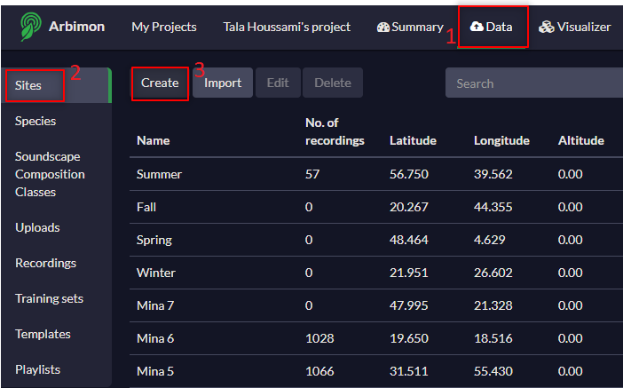

Step 3
When assigning a name to a site, refer to the relevant field procedures

site creation tips
- Drag the red map point icon onto your site to automatically acquire the GPS coordinates in the Lat/Long fields.
- You can switch between a topographical view or satellite imagery by clicking on ‘Map’ or ‘Satellite’
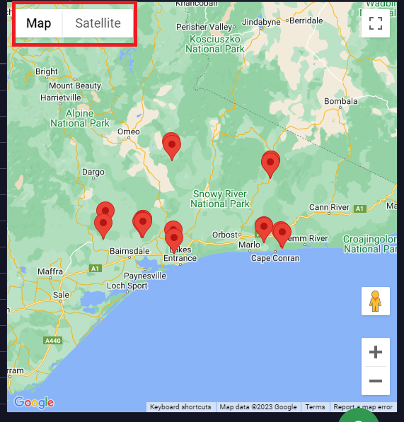

- To edit a site’s information or delete a site, click anywhere on the row of the site that you would like to modify. Click the ‘Edit’ or ‘Delete’ button.
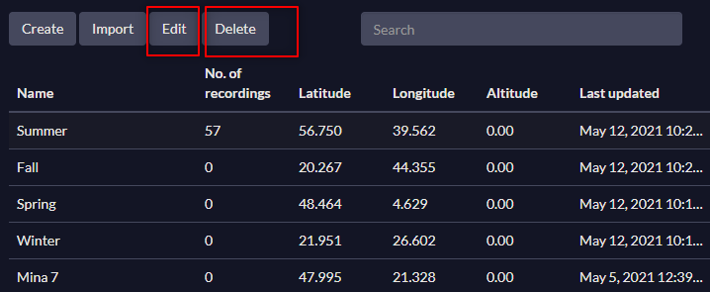

uploading audio

Whilst data can be uploaded via the Arbimon website, it is recommended that you upload using the Arbimon Uploader app. Uploads processed through the app are usually faster and less likely to fail.
The app can be downloaded from the ‘Uploads’ page in ‘Data’.
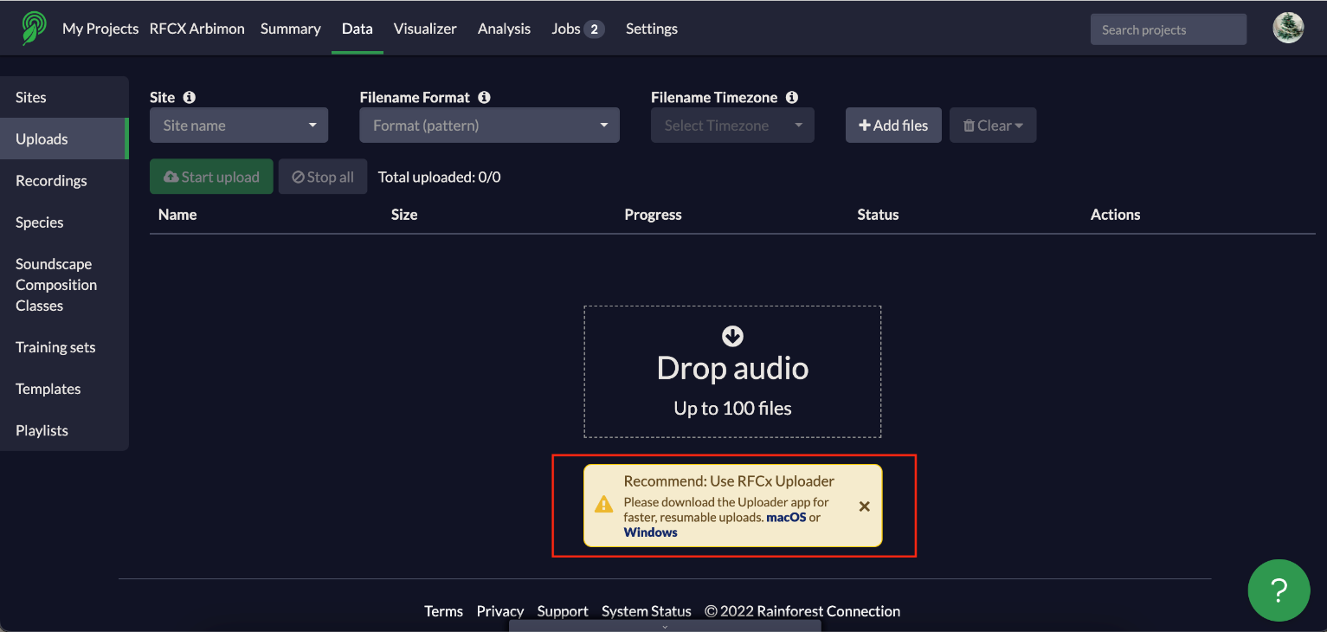

step 1

After opening the Arbimon Uploader app, you will see a login screen appear. Enter your account details and sign in.

step 2
After logging in, you can start the upload process by either dragging documents to the right part of the screen, or by pressing on ‘+Importing Files’.

step 3
You will be taken to another screen. You can choose to import files from an SD card, USB or local files (computer storage).

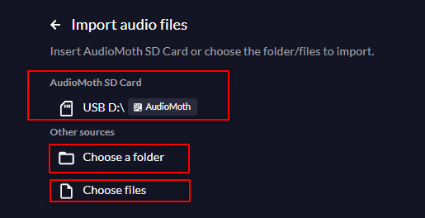

step 4
You will then be taken to a site selection screen. Your accounts projects and their subsequent sites will be available to choose from in a drop-down menu. Alternatively, if you have deployed a Song Meter with the Companion app, your projects and site will be automatically detected.
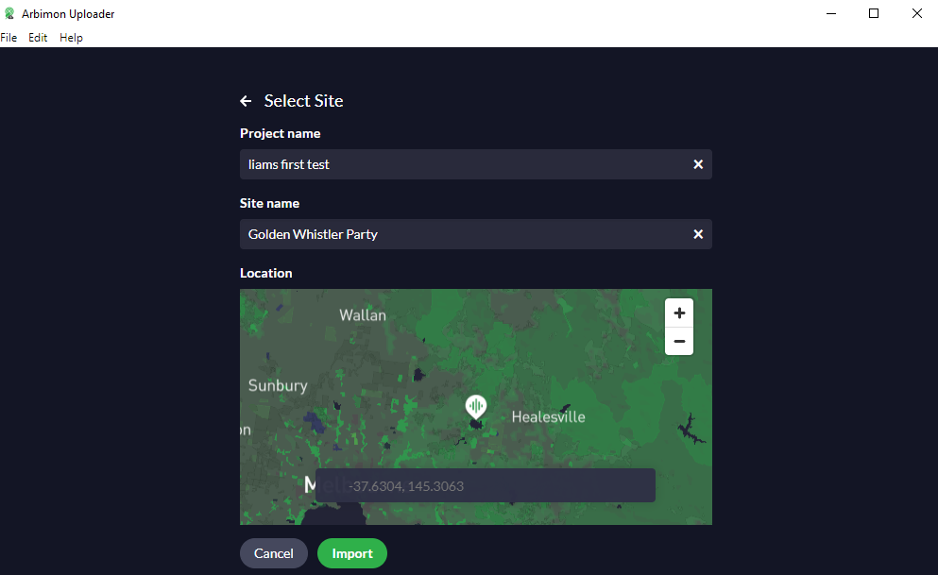

step 5
You will be taken to the ‘Preparation’ screen. Here, you can assess all your files prior to upload. There a few things on the screen here. The ‘Filename Format’ should be set to ‘auto-detect’ and the ‘Filename Timezone’ should be set to ‘Site timezone’.

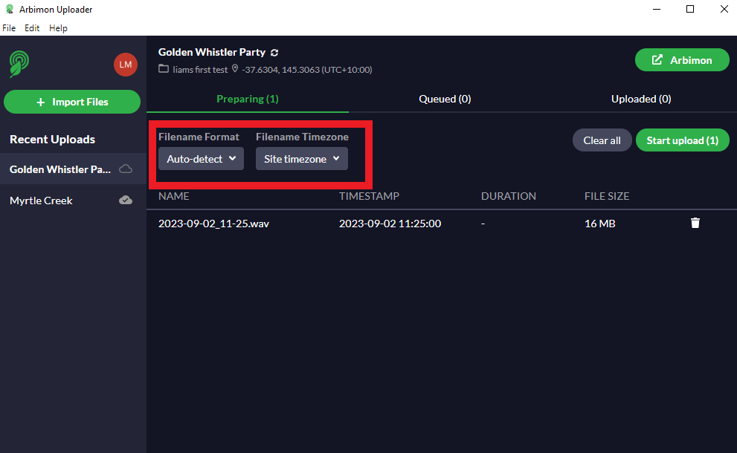

step 6
After the upload has started, each file will be queued until it has completed uploading. If you select ‘Queued’, you can:
- find the number of files that are verified
- the number of files that are completed
- the number of files that have failed.

You will be notified at the bottom of the screen when your files have completed uploading. Click on the link in the notification, or the green Arbimon button on the top-right corner to navigate back to the main Arbimon site.

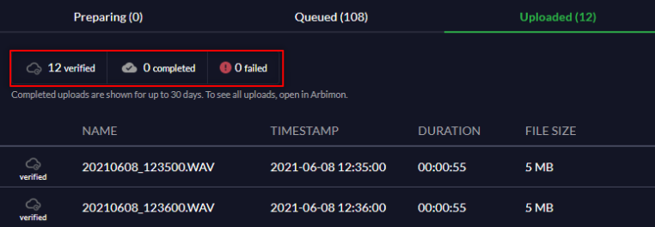
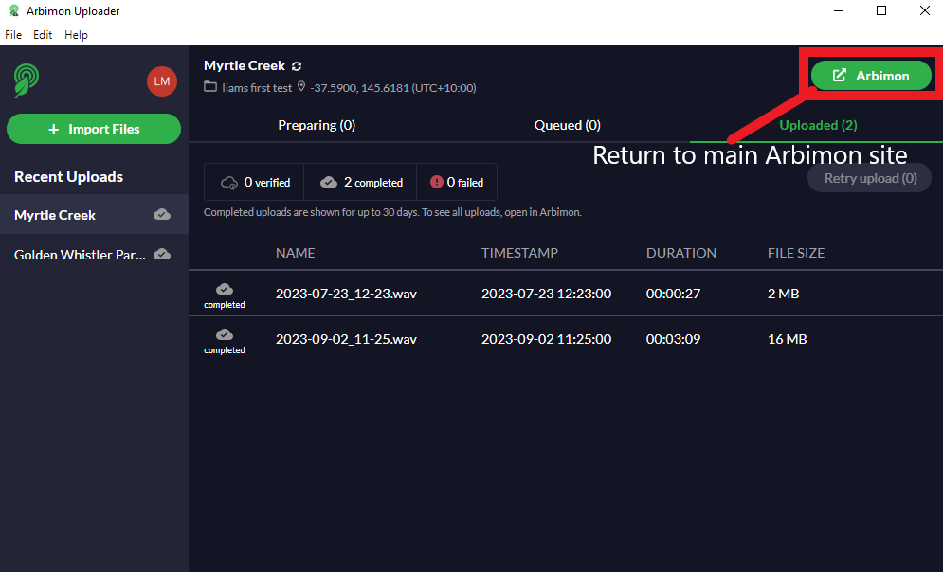

step 7
If you have made a mistake (i.e., selecting the wrong site), there is an edit option. Click the ‘Edit’ button, which will allow you to change the name, location, and project of the recording.
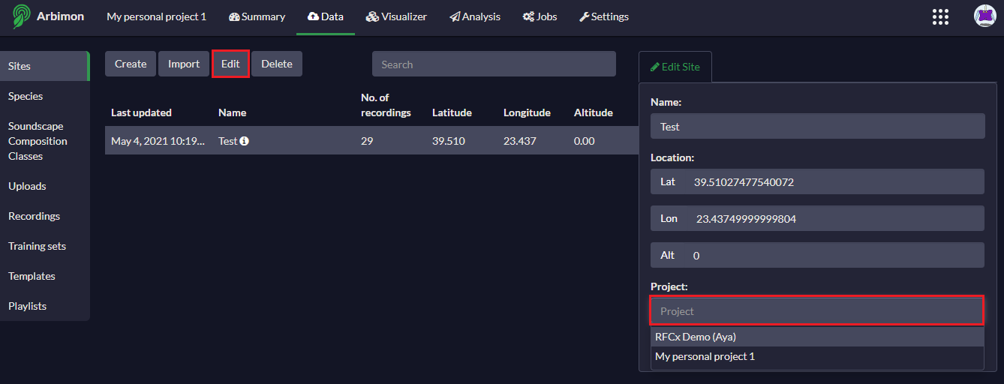

tips
If you are experiencing issues with the Uploader app, try uploading on the website.
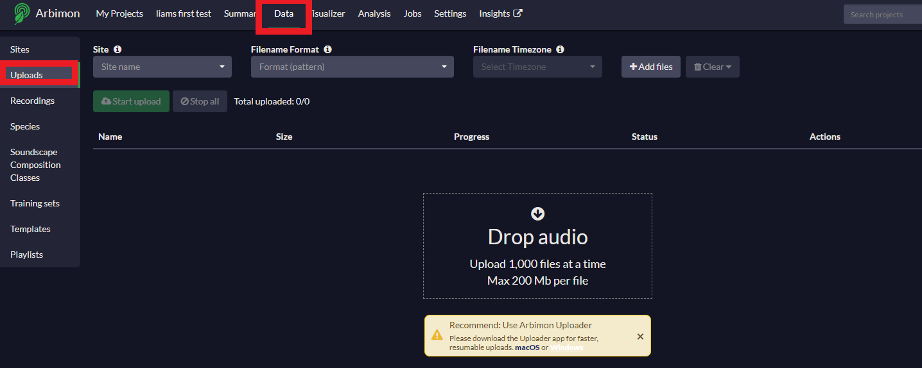
Ensure your file name corresponds with the filename format. Auto-detect is not available on the website.
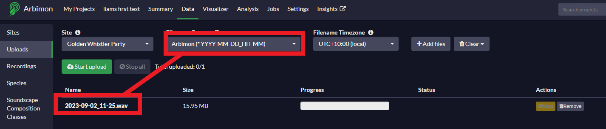

creating playlists
Playlists allow you to manage bulky data and facilitate analysis. You can make playlists to categorise individual species, habitats and dawn/dusk/nocturnal etc.

step 1
On the left menu of the ‘Data’ tab, select ‘Recordings’ to see your uploaded recordings.

step 2
Select ‘Filters’. Select among the different filter options (e.g., sites, date and time) and then select ‘Apply filters’.

step 3
Press ‘Save to Playlist’ to save the recordings set. Assign a name and then click ‘Save and Close’.

tips
Filtered recordings can also be exported as an Excel spreadsheet by selecting ‘Export’.

visualiser
The visualiser tool lets you listen to your recordings and view them as a spectrogram. It is also fundamental to the analysis of your data. For an overview of the visualiser page, see Appendix 2.

step 1
Click ‘Visualiser’ on the navigation bar. Select recordings by ‘Site’ select the date of the recordings you would like to access.
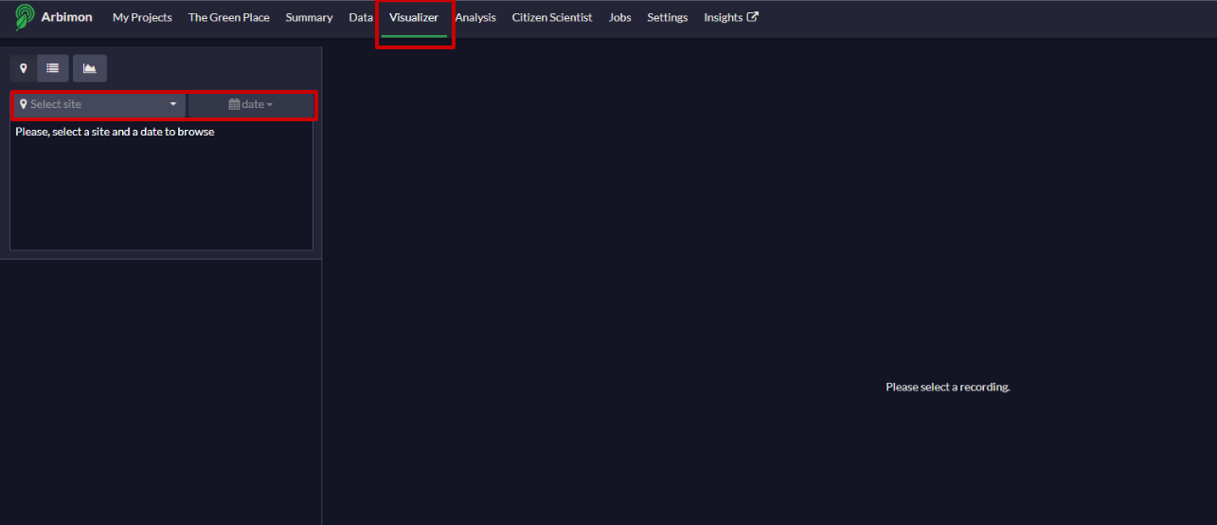

step 2
Specify where you would like to browse your recordings from. This can be from either:
- The site
- Created playlist
- Soundscape
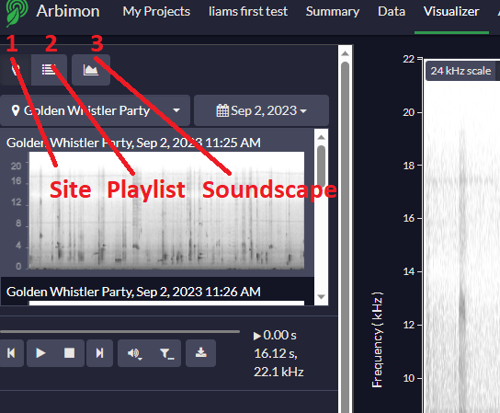
If choosing from site, you will be prompted to choose the date of recording too.

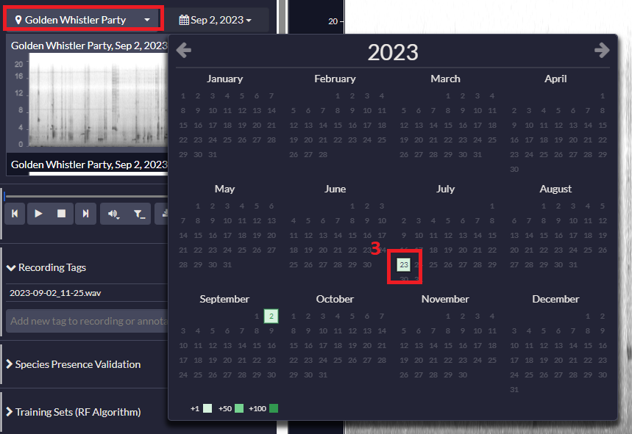

step 3
Click on the spectrogram thumbnail to open, view and listen to the selected recordings in the visualiser. Scroll down to see the next recordings.
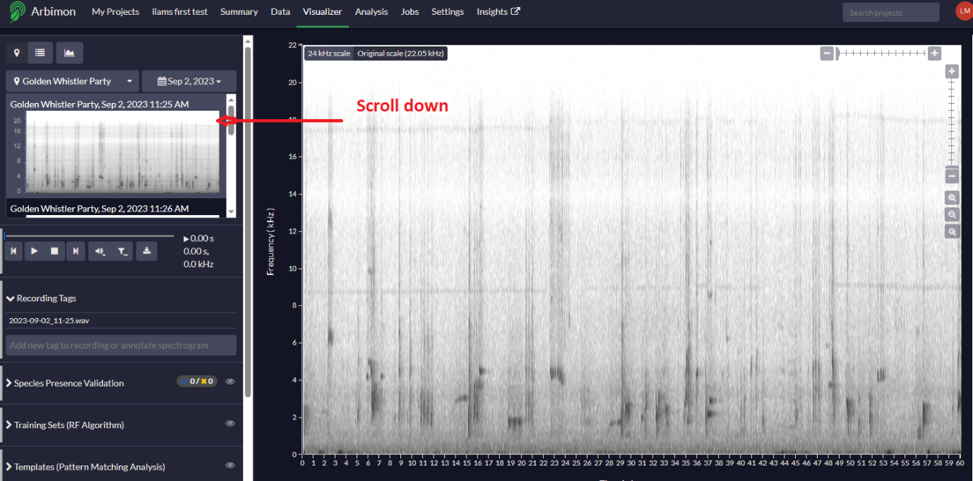

step 4
Increase the ‘Gain’ to increase the volume of the recording (at the expense of sound quality).
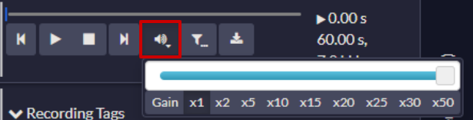

step 5
You can apply a filter to your recording, allowing you to listen to a specific frequency and cut out other noises (e.g., an aeroplane).
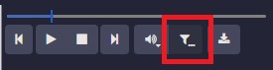
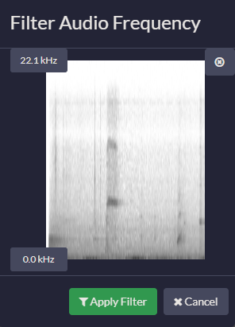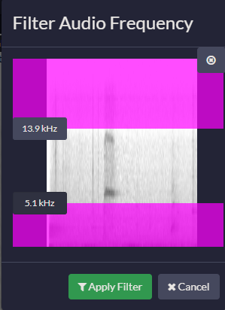

tagging recordings

Step 1
Select a spectrogram and click on ‘Recording Tags’, select the area on the spectrogram you would like to highlight and type a tag name (e.g., species name, unknown sound, double check) on the new box. Click ‘Enter’.
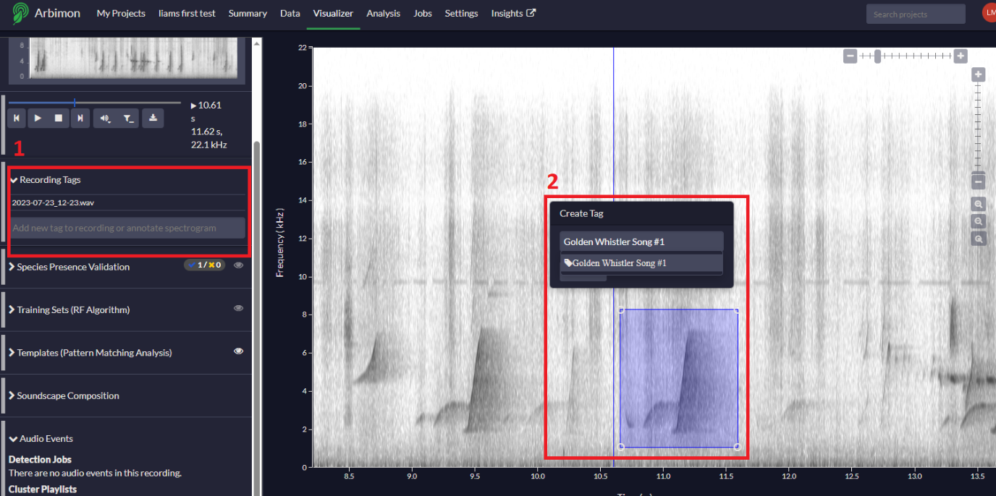

appendix 1: reference spectograms (simple calls)

Australian owlet-nightjar, aegotheles cristatus
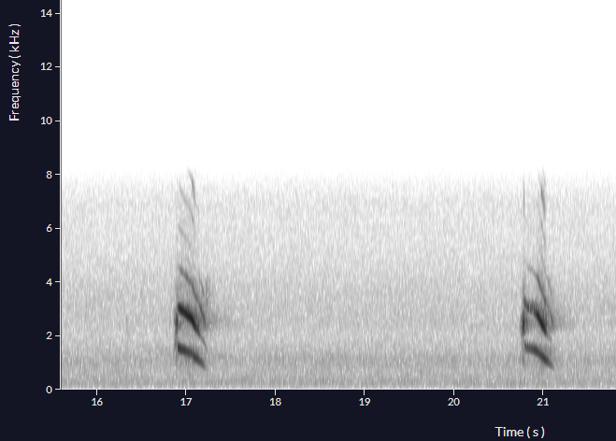

Masked owl, tyto novaehollandiae
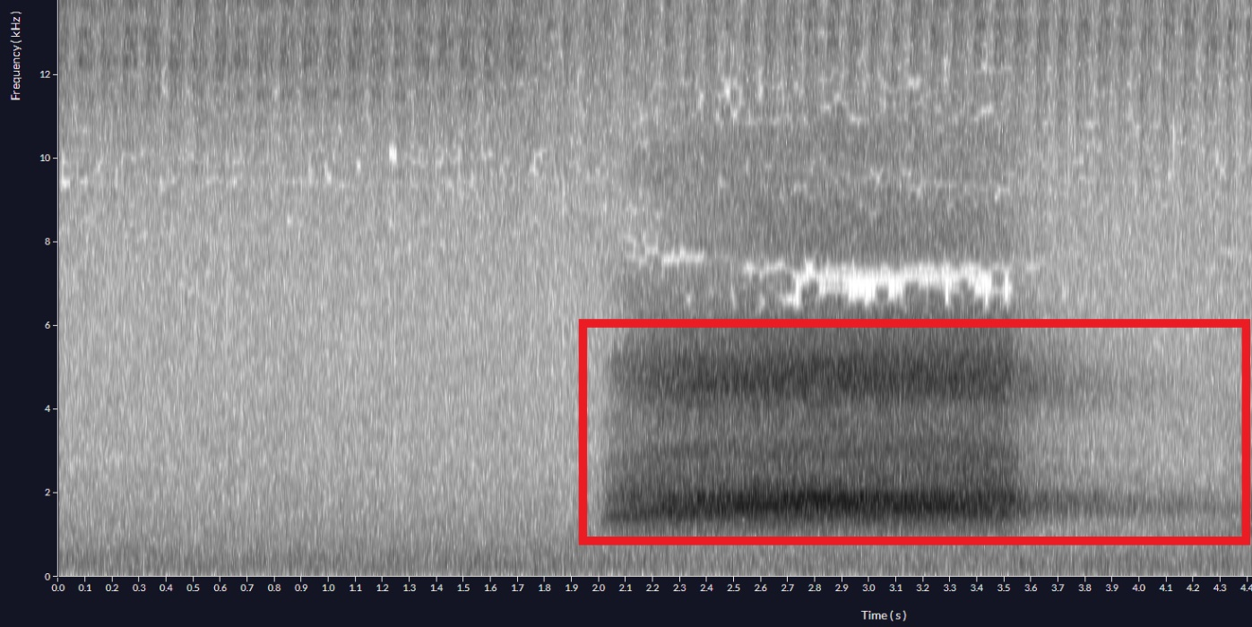

Powerful owl, ninox strenua
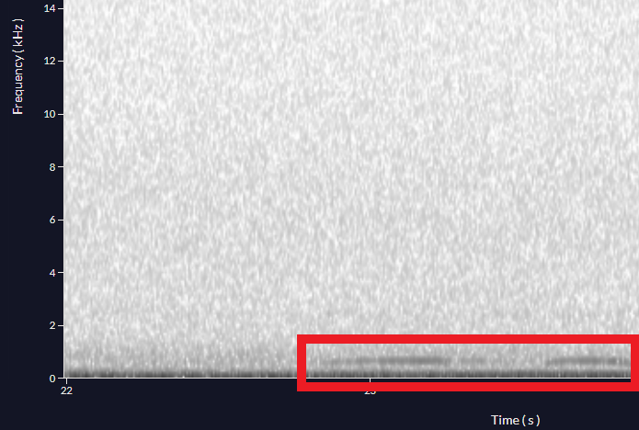

barking owl, Ninox connivens
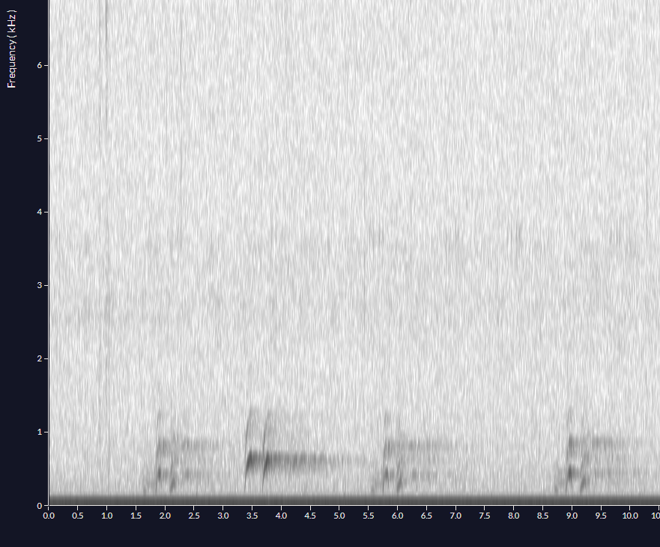

southern boobook, ninox boobook
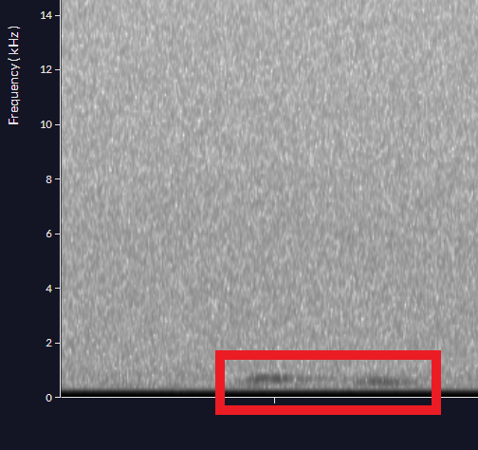

greater sooty owl, tyto tenebricosa
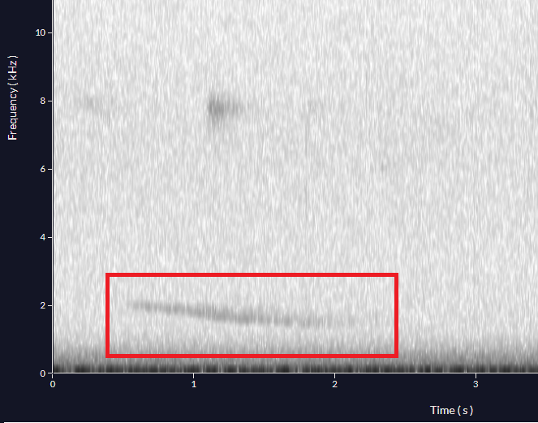

appendix 2: Ecoacoustic monitoring terminology

Amplitude
The relative strength of a sound wave, with higher amplitude sounds perceived as louder. Amplitude is determined by the amount of displacement of air particles in a sound wave.

clustering
In the context of ecoacoustics, an analytical method used to automatically partition a dataset of audio events into distinct sound types, such that sounds with similar acoustic features are clustered together.

DETECTABILITY
The probability of encountering a species in a survey. Detectability can be influenced by several factors, such as sampling effort, sampling method, type of environment, and the researcher's experience.

FALSE NEGATIVE
The failure to detect a species when it is actually present in the area; statistically a type II error in hypothesis testing.

FALSE POSITIVE
The detection of a species when it is not present; statistically a type I error in hypothesis testing.

FREQUENCY
The number of cycles per unit time, measured in hertz (Hz, cycles per second) or kilohertz (kHz, thousands of cycles per second). Perceived as pitch.

GAIN
The amount of amplification applied to an audio signal.

METADATA
Data that describes other data. Used to provide information about the content, structure, and context of data, such as a recorder’s configuration settings, location recorder was deployed, file format, and field notes. Metadata is used to help organize, manage, and make sense of large amounts of data.

NOISE
Everything except the sound(s) of interest (e.g., wind, machines, etc.)

PATTERN MATCHING
An automated sound detection algorithm that uses a single example of a target signal (i.e., the template) to search a larger set of recordings for similar signals based on a user-defined correlation (i.e., similarity) score.

PLAYLIST
A set of recordings grouped according to user-defined criteria and filters (e.g., by site, presence of a particular species, etc.). In Arbimon, playlists are an essential component for all analyses since it is necessary to select which set of recordings the analysis will be run over.

SAMPLE RATE
How many times per second that samples will be collected by the recording device. For example, if we configured a recorder with a sampling rate of 44.1kHz, it means that it was collecting 44,100 samples per second.

SIGNAL-TO-NOISE RATIO
A measure of the ratio between the strength of a signal and the strength of background noise present (i.e., how much stronger the signal is than unwanted background noise).

SPECIES COMPOSITION
The set of taxa present in a given community with or without their relative abundances. It is used to describe and compare different biological communities and can provide a useful understanding of how environmental factors affect the distribution and diversity of taxa.

SPECIES RICHNESS
The number of different taxa present in a given area. It is a simple but important metric for understanding the diversity and complexity of an ecosystem.

SOUNDSCAPE
All the sounds emanating from a specific location and time period. Composed of three fundamental sources: biophony (animal sounds), geophony (geophysical sounds), and anthrophony (human sounds). In Arbimon, soundscapes can be represented by a graph showing the amount of acoustic activity at each frequency within a time span.

SPECTROGRAM
A graphic visualization of a sound represented by frequency (pitch) on the y-axis and time on the x-axis. The color-scale in a spectrogram represents the intensity (amplitude) of a sound.

TAGS
Labels put in recordings to facilitate search and organization. For example, in a recording where there is doubt about the identification of a species, the user can include the tag "doubt" to be able to easily find the recording in the future. Users can put multiple tags within the same recording.

tEMPLATE
An example that best represents an acoustic signal of interest (e.g., a species-specific call). Templates can be used as input to Arbimon's acoustic analysis tools, such as Pattern Matching.

validation
Accurate identification and labelling of species-specific calls by an expert in the field. This can be done before or after an analysis; if the latter, the user is manually identifying the outputs of the statistical or ML tool.

Appendix 3: navigation bar overview
- My Projects: This is where you can create new projects, in addition to finding all your created projects.

- Summary: dashboard that displays project summary and progress

- Data: add and manage sites, species, and soundscape composition lists; upload, view and filter your recordings (creating playlists), compare between training sets and combine playlists

- Visualizer: browse through recordings, spectrograms or soundscapes and listen to them; validate the target species presence/ absence and create training sets for the species-specific identification models. In addition, identify the main source of the sounds that compose a soundscape.

- Analysis: run species-specific identification models, apply those models to your data (classifications), create soundscapes and audio event detections.

- Jobs: check the progress of your analyses/ uploads.

- Settings: delete the project, edit project name and description, as well as add other users to the project.

Appendix 4: Visulaiser Overview
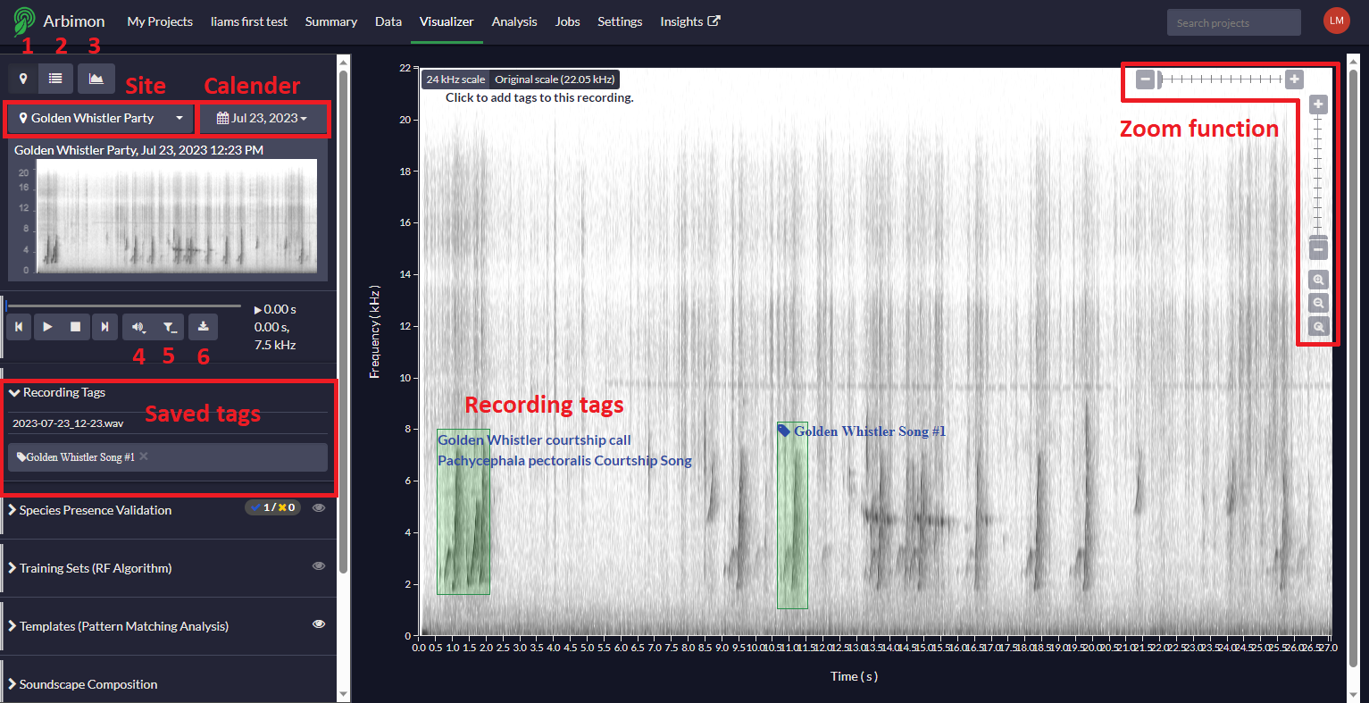
- Site selection 4. Gain
- Playlist selection 5. Filter frequency
- Soundscape selection 6. Export recordings

